Supplementary file
Title: Effect of biomarker identification on power analysis for diagnostics research

Animesh Acharjee^{1,2,3,*,#}, Joseph Larkman^{1,2,*}, Victor Roth Cardoso^{1,2}, Georgios V. Gkoutos¹⁻⁶

¹College of Medical and Dental Sciences, Institute of Cancer and Genomic
Sciences, Centre for Computational Biology, University of Birmingham, B15 2TT, UK
²Institute of Translational Medicine, University Hospitals Birmingham NHS, Foundation Trust, B15 2TT, UK
³NIHR Surgical Reconstruction and Microbiology Research Centre, University Hospital Birmingham, Birmingham B15 2WB, UK.
⁴MRC Health Data Research UK (HDR UK)
⁵NIHR Experimental Cancer Medicine Centre, B15 2TT, Birmingham, UK
⁶NIHR Biomedical Research Centre, University Hospital Birmingham, Birmingham, B15 2TT, UK.

* Corresponding Author.
Animesh Acharjee
Tel.: +44 (0)1213718135
E-mail: a.acharjee@bham.ac.uk

Supplementary Material 1 – PowerTools user manual
We will execute a case scenario to demonstrate PowerTools web interface [1]. The dataset selected is from Acharjee et al., 2017 [2]. This manual is separated in two parts: data handling and PowerTools exploration.
Data handling
Before start make sure you have a copy of the dataset. We load the dataset into Microsoft Excel [3] as shown in Figure 1. There are many columns indicating different lipid profiles and a class for each data point indicating the type of nutrition the infant had – Formula for feeding exclusively with formula, HM indicates exclusively breastfed and HM & formul indicates mix-fed. The number of samples with Formula, HM and HM & formul nutrition are 87, 85 and 67 respectively.
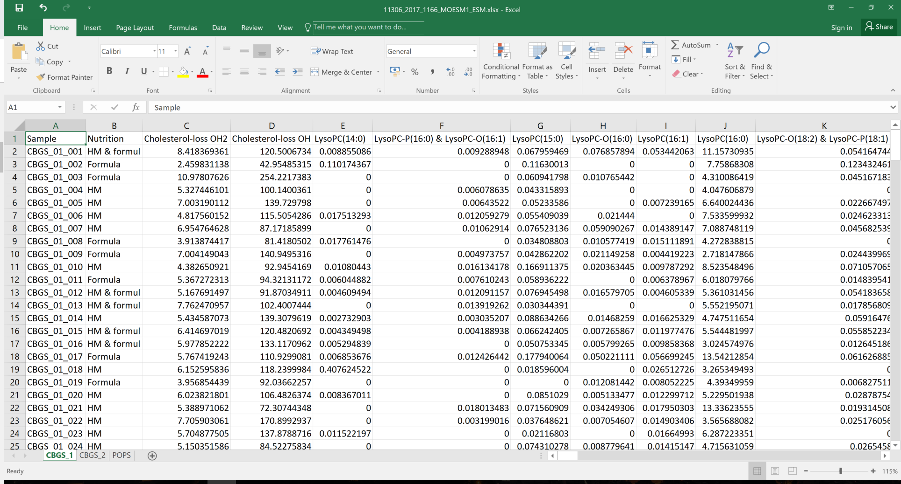
Figure 1: Loaded Archarjee et al., 2017 dataset.
We want to estimate the power when doing a classification between Formula and HM. In order to select the data to our two-class problem, we delete the HM & formul rows. We also remove the first column, and keep the two-group variable as the first column in the dataset. Figure 2 shows the resulting dataset. This file is then saved as a CSV (Comma delimited) (*.csv) format, which removes all the other sheets.
PowerTools
We start loading the PowerTools webpage [1] (link in the references). In the Data Upload tab, under Choose CSV File, click on Browse… to upload the file we created. Figure 3 exemplifies this process. After the dataset is uploaded a red message indicating Invalid data for regression mode appears in the bottom left side. Under Power Function Parameters option Outcome variable type, select Two-group Classification. A blue message indicating Data loaded appears. Change the Range of sample sizes as appropriate. In this scenario the range selected is 30 to 300. Figure 4 shows the final setting. Click Submit to start the analysis.
After click to submit the options to analysis a text box on the right side appears and the progress of the analysis is shown. After the iteration through different sample sizes and the variables available, the view changes to the Results tab, Figure 5. It is possible to visualise the variables and the estimated power given the sample size. For example, lipid TG.54.4 reaches power 1 with circa 120 samples, whilst LysoPC.20.3 with around 480 samples for using Bonferroni correction [4]. In the bottom of the page is possible to download the data for the results figure.

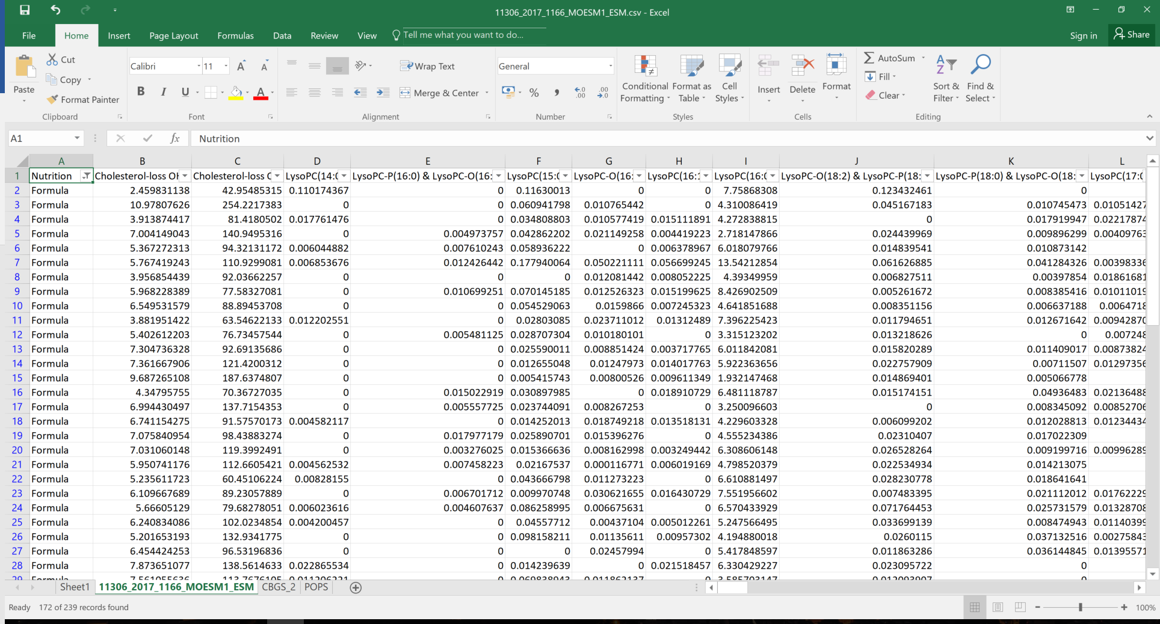
Figure 2: Dataset ready for analysis.
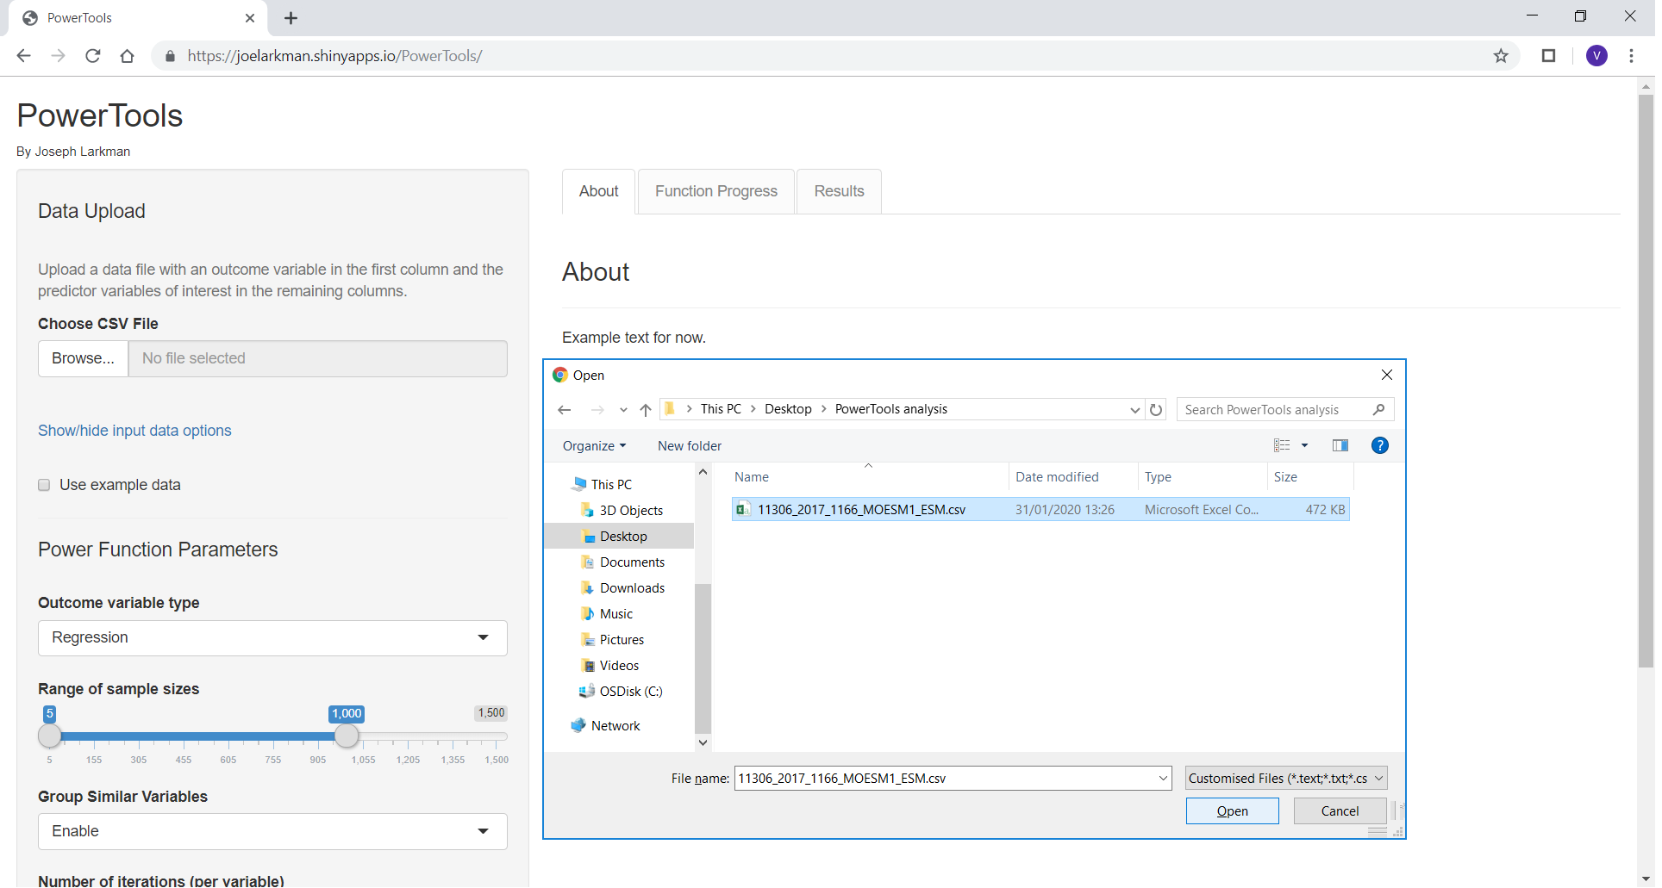
Figure 3: Loading a dataset in PowerTools webpage.
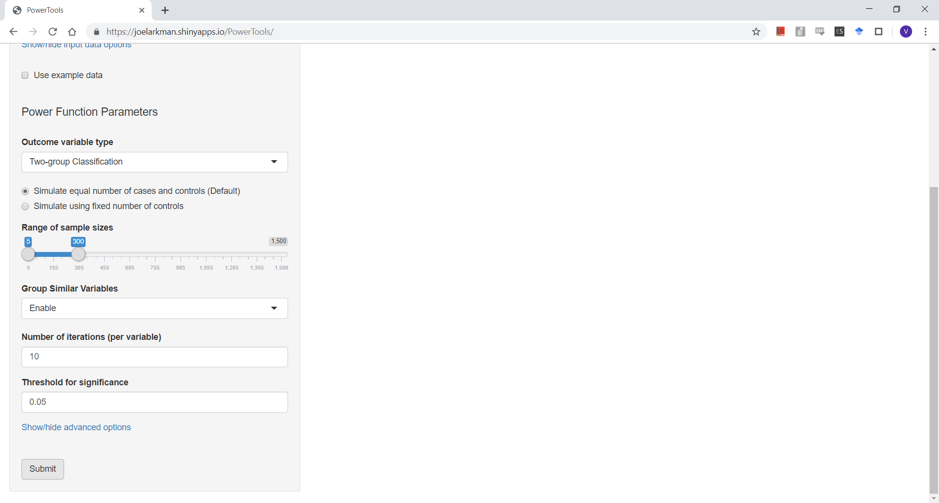
Figure 4: PowerTools options selected after uploading the dataset.
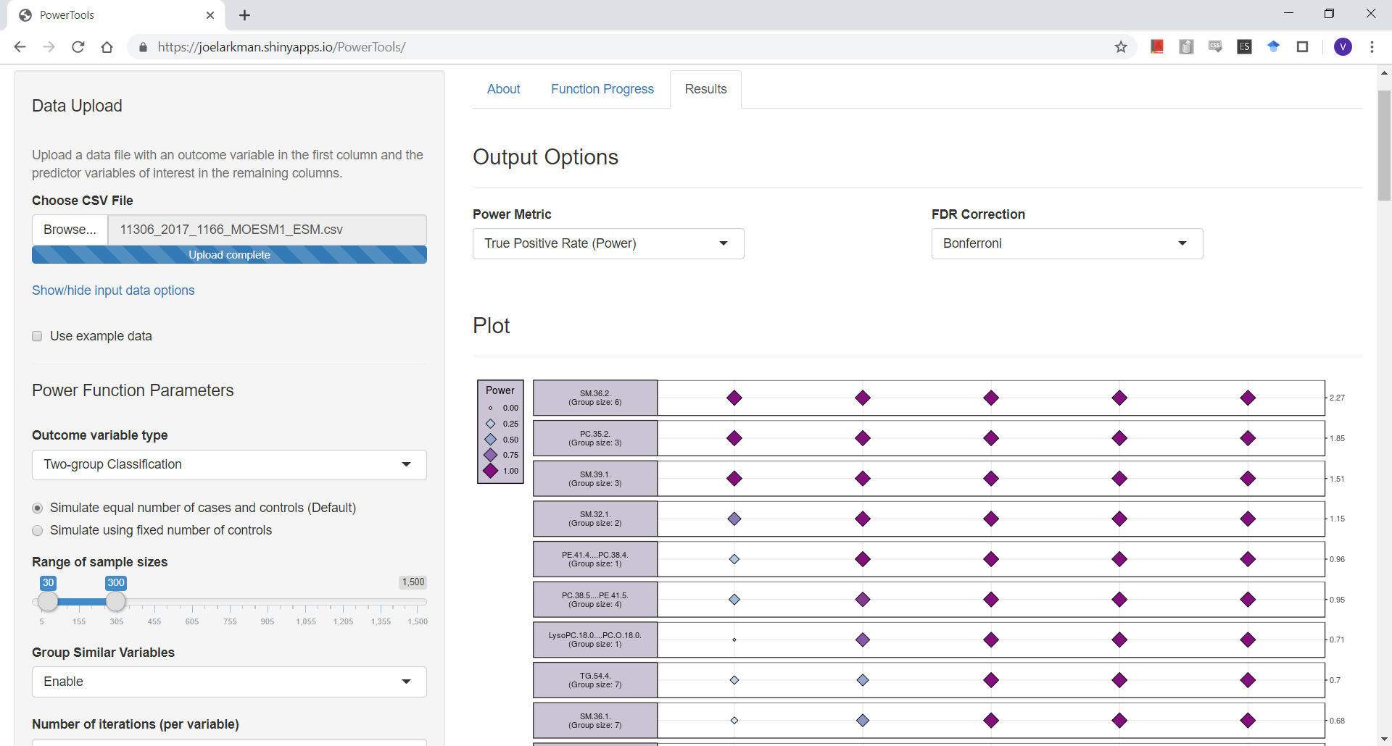
Figure 5: Results tab after finishing the analysis.

1. Larkman J. PowerTools 2019 [Available from: https://joelarkman.shinyapps.io/PowerTools/. Accessed on 30 January 2020.
2. Acharjee A, Prentice P, Acerini C, Smith J, Hughes IA, Ong K, et al. The translation of lipid profiles to nutritional biomarkers in the study of infant metabolism. Metabolomics. 2017;13(3):25. doi:10.1007/s11306-017-1166-2.
3. Microsoft. Excel. California2016.
4. Haynes W. Bonferroni Correction. In: Dubitzky W, Wolkenhauer O, Cho K-H, Yokota H, editors. Encyclopedia of Systems Biology. New York, NY: Springer New York; 2013. p. 154-.

